## **Labeling Tools in Object Detection**

### Introduction

In the field of computer vision, accurate object detection relies heavily on high-quality annotated data. Labeling tools are essential for creating these annotations, enabling researchers and developers to mark objects within images for training machine learning models. This documentation provides an overview of popular labeling tools, detailed guides on the annotation process, and instructions on exporting annotated data in formats compatible with various object detection frameworks.

### Annotation Process

Annotations in computer vision refer to the process of labeling or marking objects of interest within images or videos. These annotations provide valuable information to machine learning algorithms, allowing them to learn and recognize patterns associated with specific objects.

#### Types of Annotations:

1. **Bounding Boxes:** Rectangular or polygonal regions outlining the location of objects within an image.
2. **Class Labels:** Descriptive labels assigned to each annotated object, indicating the type of object it represents (e.g., "car," "person," "cat").

Annotations are crucial for supervised learning tasks, where a model is trained on a dataset containing annotated examples. They are essential for various computer vision tasks, including object detection, object recognition, semantic segmentation, and instance segmentation.

#### General Steps for Annotating Objects:

1. **Open the Tool:** Launch the annotation tool.
2. **Load Images:** Select the folder containing the images you want to annotate.
3. **Create a New Annotation:** Select the option to create a new annotation (e.g., "Create RectBox").
4. **Draw the Bounding Box:** Click and drag to draw a bounding box around the object you want to annotate.
5. **Label the Object:** Enter the label for the object.
6. **Save the Annotation:** Save the annotation.
7. **Repeat:** Repeat the steps for all objects in the image and move to the next image.

### Exporting Data

Exporting data in computer vision involves saving annotated data in formats compatible with various frameworks or applications. This ensures that annotations, such as bounding boxes and class labels, are preserved in structured formats like Pascal VOC, YOLO, COCO, or others. Exported data enables tasks like model training, evaluation, and integration with machine learning frameworks.

#### General Steps for Exporting Annotated Data:

1. **Choose Format:** Select the export format compatible with your object detection framework.
2. **Export:** Save the annotations in the chosen format. The annotations will be saved in the specified directory.

### Popular Labeling Tools

Here are some tools you can use for annotating images:

1. **LabelImg**
2. **Label Studio**
3. **VGG Image Annotator (VIA)**
4. **Roboflow**

Let’s see how to annotate images using this tools

### LabelImg

**Step-by-Step Process for Using LabelImg:**

1. **Install LabelImg:**
   * **Linux:**

bash

Copy code

sudo apt-get install pyqt5-dev-tools

git clone https://github.com/tzutalin/labelImg.git

cd labelImg

make qt5py3

pip install pyqt5==5.14.1

pip install lxml==4.9.1

python labelImg.py

* + **Windows:**

bash

Copy code

git clone https://github.com/tzutalin/labelImg.git

pip install PyQt5

pip install lxml

pyrcc5 -o libs/resources.py resources.qrc

python labelImg.py

* + Alternatively, use the standalone application available in the "release" section of the LabelImg GitHub page.

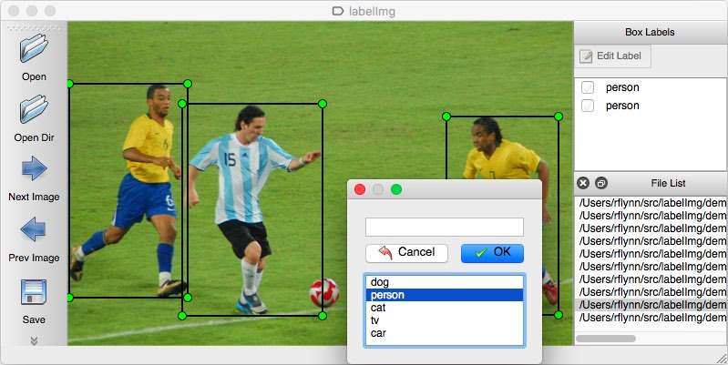

1. **Open LabelImg:**
   * Launch LabelImg by running the appropriate command in your terminal or command prompt.
2. **Load Images:**
   * Click on the "Open Dir" button within LabelImg and select the folder containing the images you want to annotate.
3. **Create Annotations:**
   * To create a new annotation, press the 'W' key or click on the "Create RectBox" button.
   * Draw a bounding box around the object you want to annotate by clicking and dragging with your mouse.
4. **Label Objects:**
   * Enter the label for the object in the popup dialog that appears after drawing the bounding box.
5. **Save Annotations:**
   * Save the annotation by clicking on the "Save" button or pressing 'Ctrl+S'.
6. **Repeat:**
   * Repeat the annotation process for all objects in the image.
   * Move to the next image using the 'D' key or by clicking the next image button.
   * Continue annotating until all images are labeled.

### Label Studio

**To annotate data using Label Studio, follow these steps:**

1. **Install Label Studio:**

bash

Copy code

pip install label-studio

1. **Start Label Studio:**

bash

Copy code

label-studio start

* + Access Label Studio at <http://localhost:8080>.

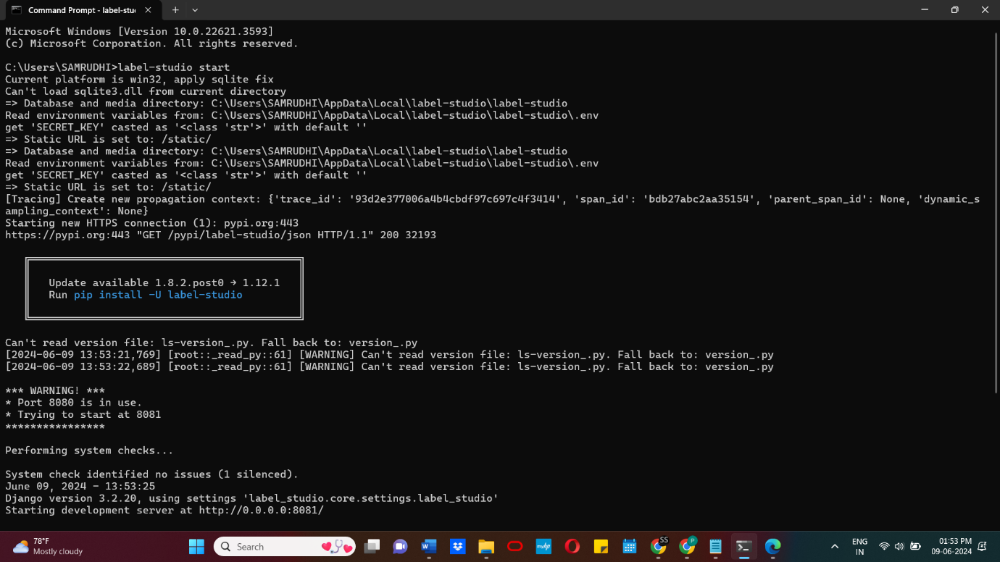

1. **Sign Up:**
   * Sign up with your email address and create a password.
2. **Create a Project:**
   * Click on "Create" to start a new project.
   * Name your project, add an optional description, and select a color.
3. **Import Data:**
   * Click on "Data Import" and upload the data files you want to label.
   * If using data from a local directory, cloud storage, or database, skip this step for now.

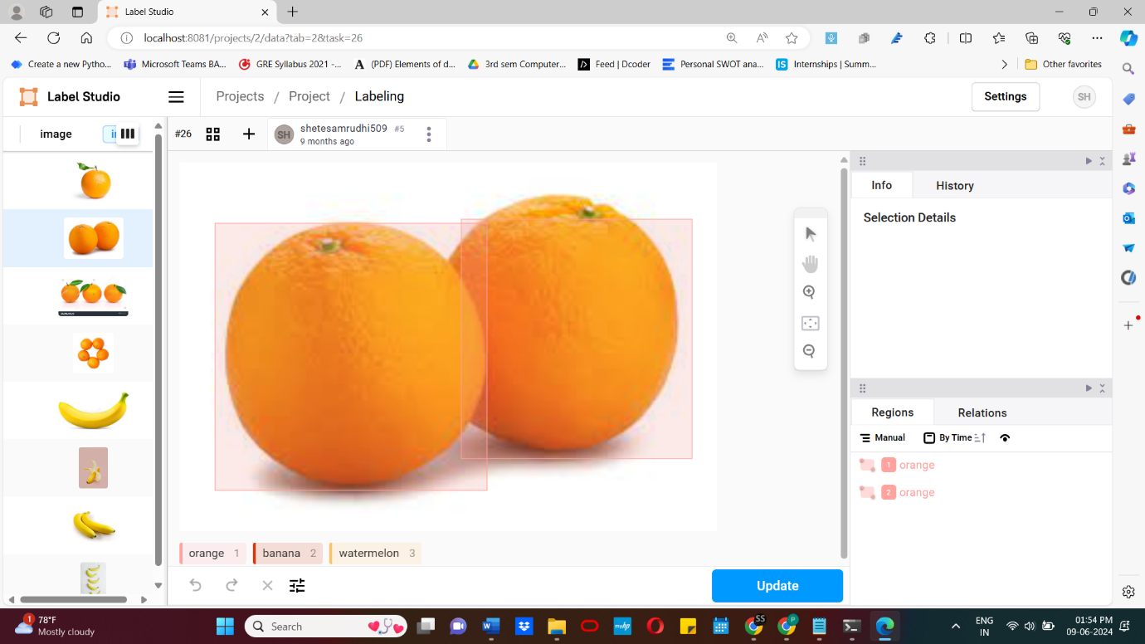

1. **Labeling Setup:**
   * Click on "Labeling Setup" to choose a template and customize label names for your use case.
2. **Save Project:**
   * Click "Save" to save your project.

### VGG Image Annotator (VIA)

**To annotate data using VGG Image Annotator (VIA), follow these steps:**

1. **Start a Project in the VGG Image Annotator:**
   * Head over to the online portal for the VGG Image Annotator.
   * Define the project you are working on using the left-hand sidebar.
2. **Load Images into the VGG Image Annotator:**
   * Click on "Add Files" on the left sidebar.
   * Select the files from your local drive for upload.
   * Your image files will load in the left-hand sidebar.

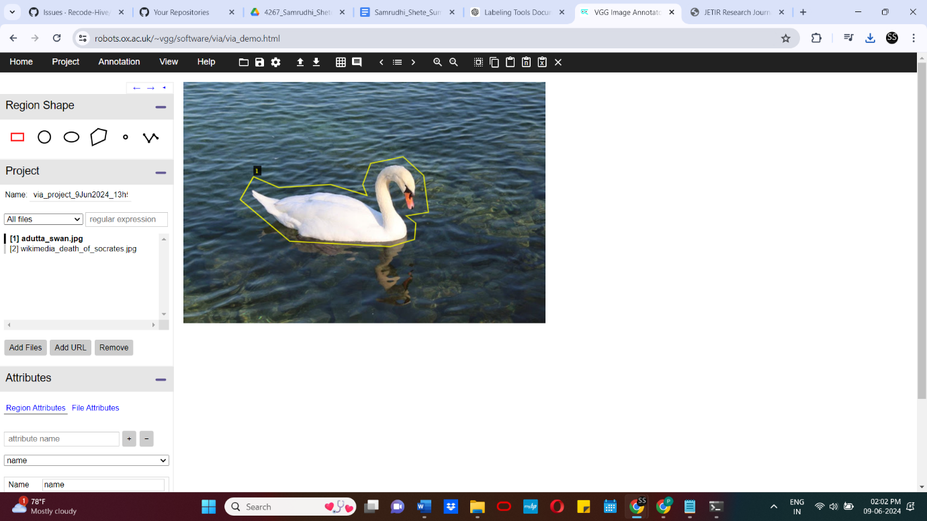

1. **Labeling Images in the VGG Image Annotator:**
   * Choose the shape of the annotation you would like to make (e.g., bounding box, polygon) from the left-hand sidebar.
   * Click and draw your annotation around the object you would like to label.
2. **Assigning Class Labels to Your Annotations:**
   * Define a Region Attribute by naming it (e.g., "class-label").
   * Choose the type of field to assign to that attribute (e.g., dropdown with options for class labels).
   * Hit the Space Bar to toggle the annotation pane.
   * Fill in the Region Attributes for each of your labeled objects.
3. **Exporting Data from the VGG Image Annotator:**
   * Once you have finished labeling your dataset, click on "Annotation" in the upper left and then "Export Annotations as CSV."
   * This will download a CSV file to your local storage.

### Roboflow

**To annotate data using Roboflow's annotation tool, follow these steps:**

1. **Access the Labeling Interface:**
   * Select an image from the Assign or Dataset pages on the Roboflow dashboard to open the labeling interface.

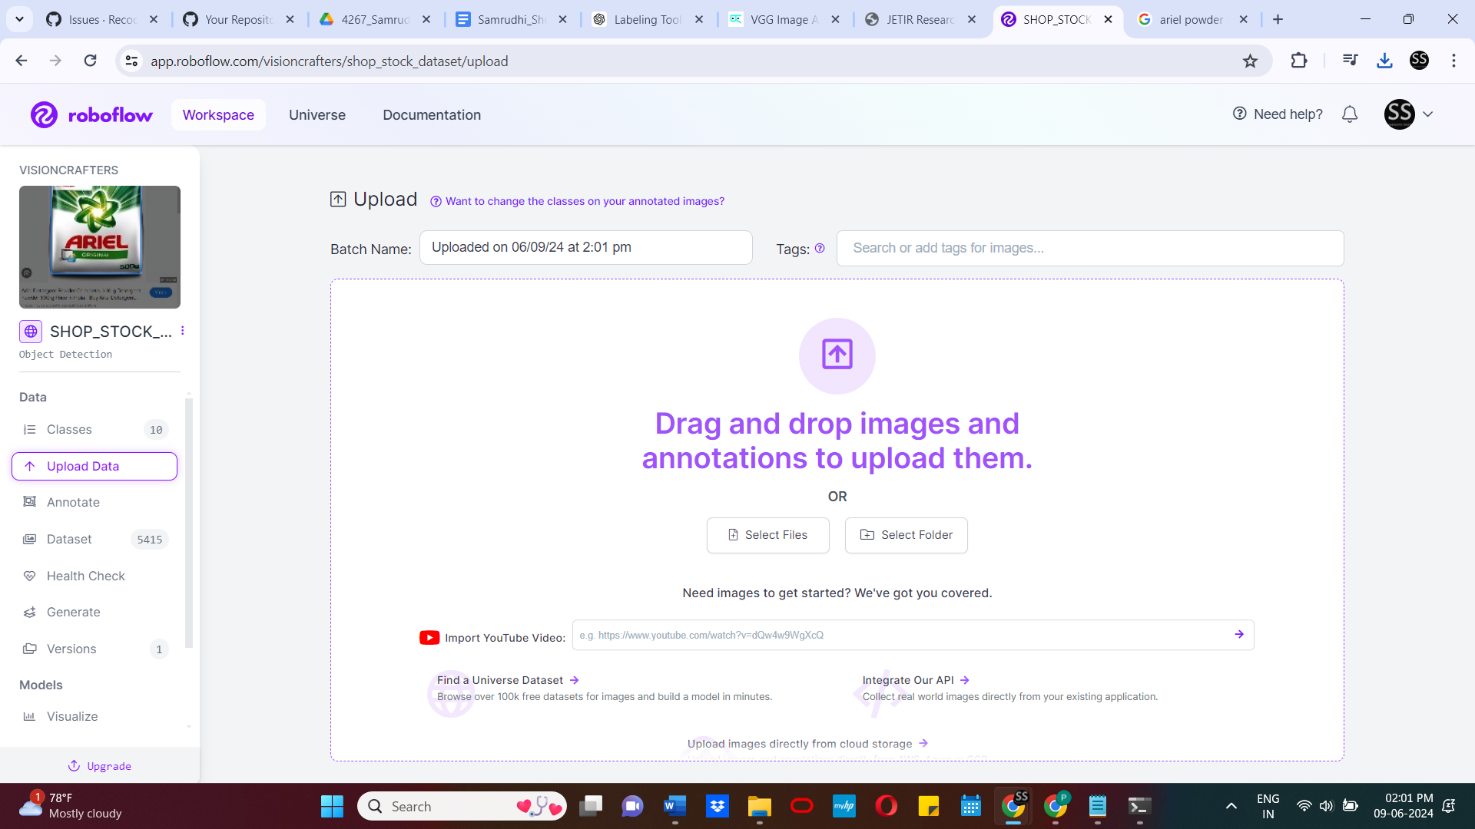

1. **Use the Toolbar Features:**
   * **Drag and Select:**
     + Represented by a hand icon. Select, edit, and drag individual annotations.
     + Single-click a bounding box to select it, change its size using the circular white handles, or change the box's label.
     + Drag the box to move it or drag the background to pan.
     + Use the Drag Tool (D) for selection.
   * **Bounding Box Annotation Tool:**
     + Represented by a rectangular box icon. Draw new bounding-box annotations.
     + Click and drag across the image to create an annotation, then select its label using the Class Selector.
     + Use the Bounding Box Tool (B) for selection.
   * **Polygon Annotation Tool:**
     + Draw new polygonal annotations by clicking around objects of interest to create an enclosed polygon.
     + Use the Polygon Tool (P) for selection.
   * **Smart Polygon:**
     + Draw Smart Polygon annotations with green and red dots for adding or removing areas of interest.
     + Useful for segmentation projects.
     + Use the Smart Polygon (S) Tool for selection.
   * **Label Assist:**
     + Use a Public Model or your own dataset version for automatic application of bounding box labels to images.
   * **Zoom Tool:**
     + Zoom in and out for detailed editing or to fit more of the image on your screen.
     + Found at the bottom left of the screen with options to lock the zoom percentage or reset it.
2. **Annotations List:**
   * The annotations sidebar shows which classes are present in an image, their box colors, and label layering.
3. **Image Attributes:**
   * Represents information about the image such as dimensions, last-modified time, and whether it is in the training, validation, or test set.

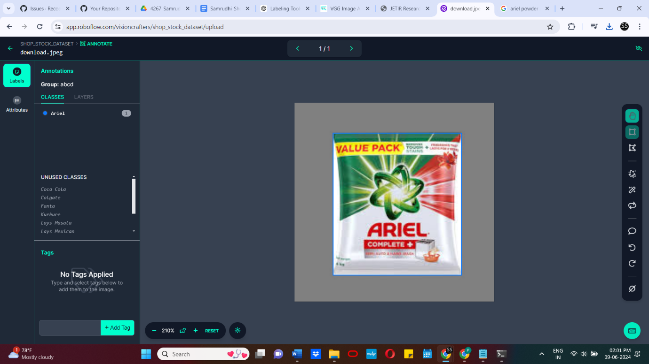

1. **Workflow for Team Annotation:**
   * **Inviting Team Members:**
     + Visit the invite page to add your colleagues.
   * **Uploading Images for Annotation:**
     + Create datasets for each team member responsible for labeling a portion of the images.
     + Name each dataset accordingly (e.g., "Chess Pieces - Joseph" and "Chess Pieces - Brad

**Conclusion:**

High-quality annotated data is crucial for the success of object detection models in computer vision. The use of robust and efficient labeling tools significantly enhances the accuracy and reliability of these annotations. This documentation has provided an overview of several popular labeling tools, including LabelImg, Label Studio, VGG Image Annotator (VIA), and Roboflow, each offering unique features and functionalities to suit various annotation needs.

By following the detailed guides provided for each tool, researchers and developers can efficiently annotate their datasets, ensuring precise and consistent labeling of objects. Additionally, understanding the annotation process and the importance of exporting data in compatible formats ensures seamless integration with machine learning frameworks, facilitating the development, evaluation, and deployment of object detection models.

In summary, the right choice and proper use of labeling tools are instrumental in preparing high-quality annotated datasets, which form the foundation for building robust and accurate object detection systems. By leveraging these tools, practitioners can enhance the performance of their models and contribute to advancements in the field of computer vision.